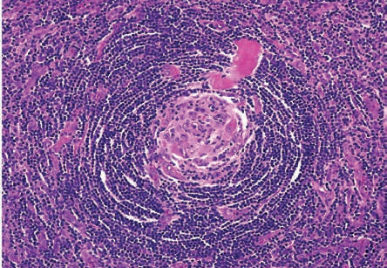

Fig. 1. Histology reveals small lymphocytes arranged in a concentric onion-skin pattern. These morphological features are characteristic of Castleman’s disease.^{[3]}

