Figure 1
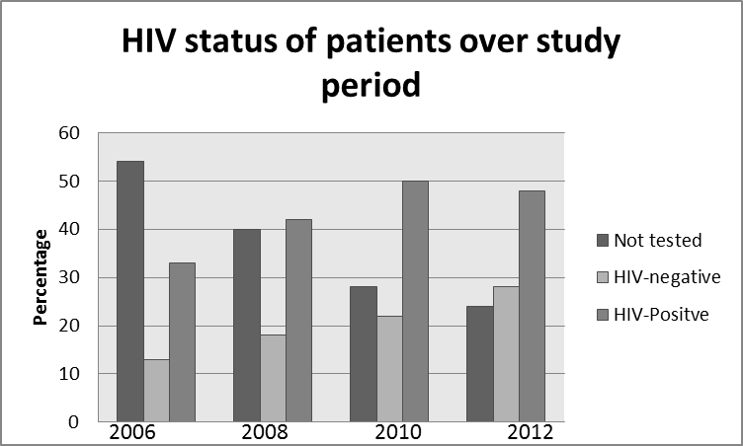
The number of patients tested and found positive for HIV infection clearly increased over the study period.

Figure 2

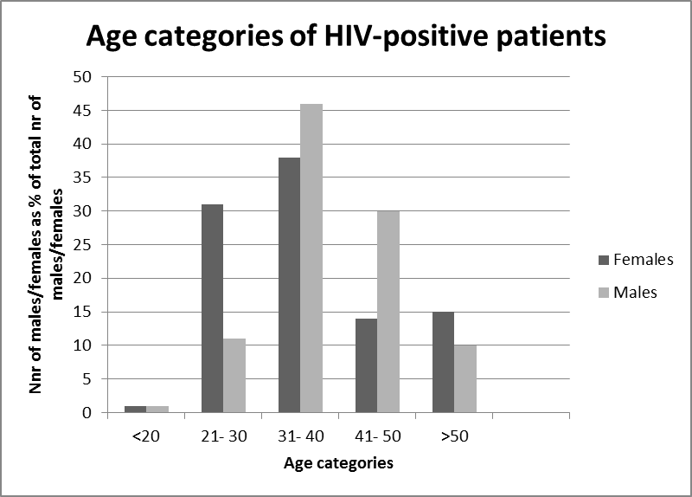

The study suggested that females died at a younger age from neurological complications of HIV infection than their male counterparts.

Figure 3
