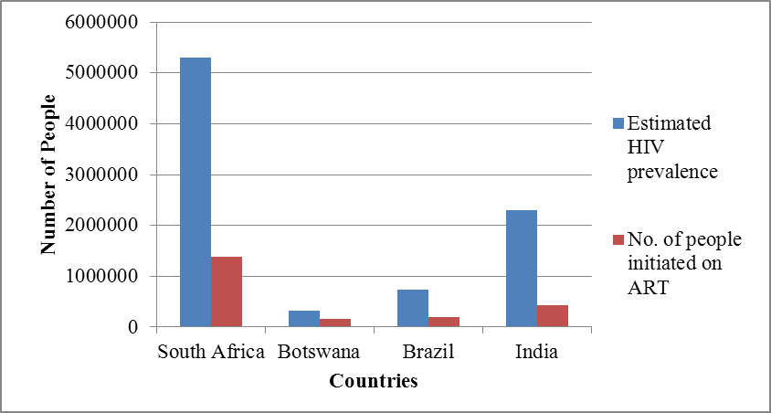

Figure 1. HIV prevalence and ART rollout in 2010